**Welcome to Loxley CE Community Primary School**



**A Guide To Starting Our School**

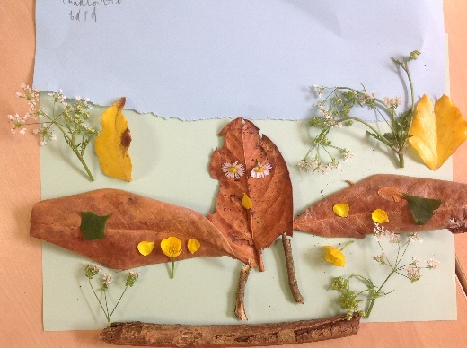

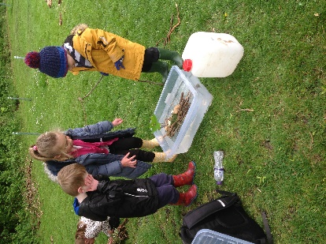

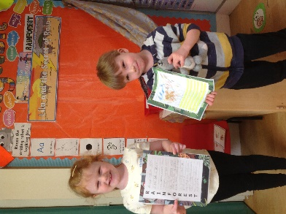

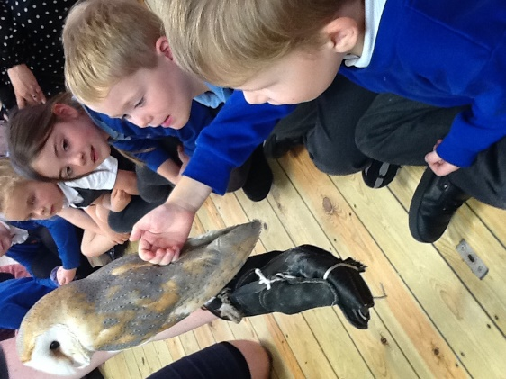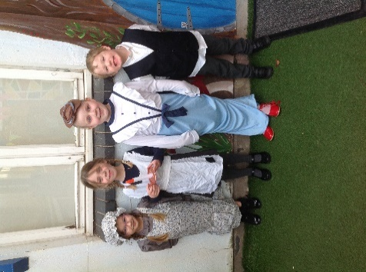

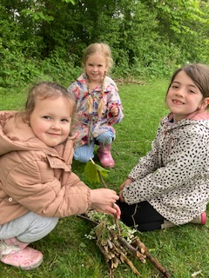

Contents

Welcome from the Head of School 3

Our History 3

Starting School 4

The Early Years Foundation Stage 6

How Can I Help My Child In Reception 8

‘Friends of Loxley School’ Association 10

Meet the Acorn Team 11

A Typical Day in Reception 12

Forest School 14

The Book Bag and its Contents 15

General Information 15

Free School Meals and Pupil Premium 16

Milk 16

Parking 17

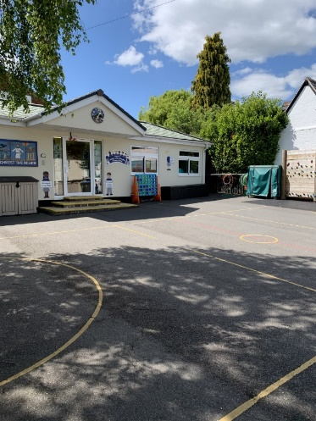Absences 17

Family Holidays 17

Medicines 18

School Uniform 18

Rules and Rewards at Loxley 20

Term dates 22

Contact us 23

**Welcome to Loxley**

I am extremely happy to extend a very warm welcome to you and your family to Loxley CE Community Primary School. We are extremely proud of our unique setting and are confident that we can provide a bespoke and individualised learning environment to meet the needs of all of our children, forming our mission statement: *‘Where individuals flourish’*.

At Loxley, we nurture a warm and caring environment and we pride ourselves on knowing our school community personally, from the children who attend our setting, to their parents and families. We believe that this strong, mutual partnership between home and school is the key to realising your child’s potential, both academically and socially during their time with us.

Our inclusive ethos is firmly rooted in Christian values and we work in close partnership with our local church to equip our children with essential values for life, whatever their faith or background. Being a Church of England school, we also visit the church throughout the year, especially at key times in the Christian calendar – such as Harvest, Remembrance, Christmas and Easter.

Officially the smallest primary school in Warwickshire, the children learn together in small mixed-aged classes, allowing the flexibility for individuals to progress at their own pace. We offer unparalleled ratios of adult-child support within a broad, balanced and exciting curriculum.

At Loxley School we are very lucky to have an exceptionally talented, dedicated and hard-working staff who work closely with parents to ensure that together, our children are empowered to flourish in every way possible.

**Our History**

There has been a school here in the village of Loxley since 1870 and we even have an amazing handwritten log book detailing the events in school from 1927. The collaboration between school, village and wider locality remains as strong as ever, with many exciting community events organised throughout the year including the ever-popular Loxley Fireworks and Bonfire Night and the summer Strawberry Fair.

**Starting School**

Starting school is such an exciting time for everyone, though it is an enormous change and it may take a little time for both parents and children to adjust to their new routines. Hopefully, this overview will make that process much easier.

* Before the end of the summer term, we will contact your child’s nursery to arrange to visit them in their present setting. This is a great opportunity to meet children in their current provision and share transition information to help them get off to a flying start with their school journey come September.

Settling In Sessions

We would also like to offer your child some opportunities to come into school and spend some time familiarising themselves with their new environment as they begin building positive relationships with the staff who will care for them and support their development.

**1. Wednesday 6th July: Jungle Jamboree Family Picnic from 1:30 – 2:30 pm**

Mums, Dads and younger siblings are welcome to accompany our new Reception starters to our Jungle Jamboree Picnic. Meet us at the school gate on **Wednesday 6th July** at **1:30 pm** so your family can join our current Acorn Class pupils and staff as we head down to the field for some jungle-themed fun! Our children will have eaten lunch but a few snacks will be provided for all the children to share. You are, of course, welcome to bring your own snacks if your child would prefer this or has specific dietary requirements. Your child will be able to join in with a few games and activities with their new classmates before ending the session with a story with one of their new Class Teachers. Your child is very welcome to bring their favourite cuddly toy or animal with them to this picnic as we will encourage our existing Acorn learners to do this too.

**2. Friday 8th July: Parents Meeting with children in Acorn Class**

Your child is welcome to come into Acorn Class on Friday 1st July from 10am to 11am. Parents and carers are then invited to join Mrs Woolley in the hall for a welcome meeting while the children explore their new classroom.

**Please let Mrs Ward in the office know if you are able to join us for these dates. (01789 840211)**

Due to the small nature of our school, there is no need for any staggered induction in September. This means that we are happy to welcome all children into school full-time from **Wednesday 7th September 2022 – 8:45am - 3:15pm.**



**The Early Years Foundation Stage (EYFS)**

The Early Years Foundation Stage is a distinct stage with its own identity. We hope to continue the positive start your child has already had in their preschool setting by offering learning experiences that are both adult-led and child-initiated.

**Child Centred Approach**

Starting with your child and what they know, we build on their success, always making activities enjoyable and challenging. We want to use their curiosity and enthusiasm to stimulate and develop a learning style that is suited to their needs. We believe that children learn best when they are happy and confident.

**Active Learning**

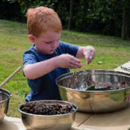The EYFS is a hands-on, organised, play based (and sometimes quite messy!) curriculum. We do use aprons and washable resources where appropriate, but please be aware that children can still unintentionally mark their uniforms. All activities are carefully planned to move children forward in their acquisition of skills, concepts and knowledge of the world around them. The planning covers all areas of the EYFS and provides children with new and exciting opportunities. Our learning environments are carefully arranged to be rich and stimulating.

The three **Prime Areas** (listed below) are fundamental, work together and support development in all other areas:

**Personal, Social and Emotional Development** - Children learn to play co-operatively, taking turns with others. They discover how to show sensitivity to others’ needs and feelings and form positive relationships. They develop skills to speak in a familiar group, talk about their ideas, and choose the resources they need for their activities. Children will talk about how they and others show feelings and talk about their own and others’ behaviour. They learn to work as part of a group or class, and understand and follow the rules.

**Communication and Language** - Children develop skills to listen attentively in a range of situations. They listen to stories, accurately anticipating key events and respond to what they hear with relevant comments. They answer ‘how’ and ‘why’ questions about their experiences and express themselves effectively, showing awareness of listeners’ needs. Children learn to develop their own narratives and explanations by connecting ideas or events.

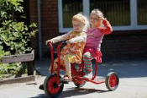**Physical Development** - Children develop control and coordination in large and small movements. They move confidently in a range of ways and handle equipment and tools effectively. Children will learn to demonstrate balance and coordination when playing. Fine motor skills will be developed to support children to show accuracy when drawing and to hold a pencil effectively in preparation for fluent writing.

The four **Specific Areas** (listed below) include essential skills and knowledge for children to participate successfully in society:

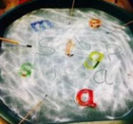**Literacy** - Children learn to read and understand simple sentences. They use phonic knowledge to decode regular words and read them aloud accurately. They also demonstrate understanding about what they have read. Children learn to use their phonic knowledge to write words in ways which match their spoken sounds. They become able to write simple sentences which can be read by themselves and others.

**Mathematics** – Children learn a deep understanding of number to 10, including the composition of each number. They will learn to subitise (recognise quantities without counting) up to 5. Children will verbally count beyond 20, recognising the pattern of the counting system. They will compare numbers up to 10 in different contexts. Children will explore and represent patterns within numbers up to 10, including evens, odds, double facts and how quantities can be distributed equally.

**Understanding the World** - Children learn about past and present events in their own lives and in the lives of family members. They talk about the features of their own immediate environment and how environments might vary from one another. Children know some similarities and differences between religious and cultural communities in this country.

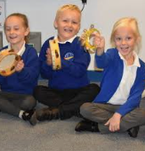**Expressive Arts and Design** - Children learn songs, make music and dance. They safely use and explore a variety of materials, tools and techniques, experimenting with colour, design, texture, form and function. They learn to represent their own ideas, thoughts and feelings through design and technology, art, music, dance, role play and stories.

**How can I help my child in Reception?**

**Talking and listening**  
Two-way communication is really important for Reception children — not to mention their anxious parents!  If you have any worries or concerns do please speak to Miss Wiffen or Miss Galgey about them. By talking concerns through together everyone can benefit and learn more about your child.

Your child will be informally observed throughout their time in Reception and the staff will use these observations to assess their learning.  You can do this too by making simple informal observations at home. Note any WOW Moments on the Amazing Acorns (which will be provided in September) and these will then be displayed in the classroom, so that everyone in Acorn class can celebrate with them. (Further information will be provided in September.)

**Read, read, read**Read to your child and encourage them to read to you. Read anything and everything, not just the reading scheme books. Real books, with pictures, rhyme and enjoyable stories are crucial here. Try to encourage your child to talk about the pictures, or to make predictions about what will happen next. It’s most important for your child to enjoy reading above all, so try to relax.

Encourage your child to recognise and read print when you are out shopping, on the bus or at the park. Most children can recognise the Golden M for McDonald’s a mile away!

Fill in their Reading Diary each time you read with your child or go through their phonics book. This can be a really useful communication tool, so the more info you provide the better!

**Help with phonics**Talk to your child about individual letters and their sounds. Singing songs and nursery rhymes really helps them to find out more about letters and sounds. Play I-spy when you go out (using the sound the letter makes, rather than its name).

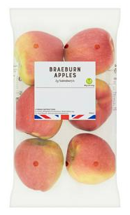**Talk numbers**There are all sorts of ways to encourage number recognition. Try to involve your child in using numbers at home by singing number rhymes and songs or by encouraging them to recognise and read numbers when you are in the car. When shopping, ask them to select the number of apples or bananas you need — they’re helping you out, and learning at the same time.



**Getting dressed independently**And finally, (and on a more practical note!), it is really useful if you can encourage your child can have a go at dressing themselves at home so that they can do themselves during the day. It’s often quite time-consuming for staff to have to do up lots of zips on wriggly children bursting to go outside!





**Other ways to be involved…**

As a school, we are lucky to have a very active and supportive PTA, ‘Friends of Loxley School’. ‘FOLS organise a range of fundraising events throughout the year, including the ever-popular Bonfire and Fireworks Night, the Christmas Fair and the Summer Strawberry Fair. ‘FOLS’ are a fun and friendly group who are always looking to recruit more volunteers to help in any way possible. Please see the ‘FOLS’ information page below for more details.

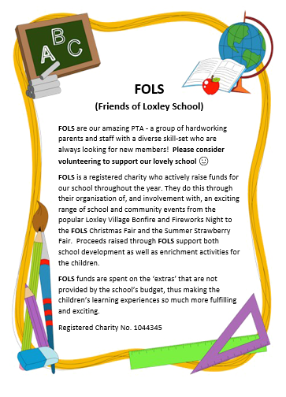

**Meet The Acorn Team**



**Miss Galgey teaches on Mondays and Tuesdays**



**Miss Wiffen Teaches on Wednesdays, Thursdays and Fridays**



**Mrs Russell is our full-time Teaching Assistant**

**A Typical Day in Reception**

**8.40am**

The gate is opened.

**8.45am**

The door to Acorn classroom is opened - children can begin to come inside and put their coats, book bags, lunchboxes and water bottles away.

A member of staff is always on hand to greet children and parents at the gate in the morning and to take any messages. However, if you need to speak to your child’s class teacher at length and it is not urgent, **please wait until the end of the day as they will have more time to talk and fewer children who need them!**

**Please ensure that your child’s teacher is informed of any changes to collection arrangements for that day either verbally or via a note. If plans for collection change during the day please contact the school office so they can inform your child’s teacher.**

**Class teachers will not let children go home with adults they don’t know or recognise or with parents of other children in the class unless they have been informed of these arrangements before.**

**8.55am**

All children should be in school by this time as the school gate is locked promptly at 8.55am.

Should you arrive after 8.55am, please press the gate buzzer so that Mrs Ward from the school office can sign them in and then taken to their classroom. They will also be asked to choose their hot dinner (this must be ordered by 9.30am).

**9.05am**

Children begin their learning in their classrooms and outdoor areas.

Throughout the morning, the children may help themselves to a snack and have a drink from their water bottle. Fresh fruit is provided daily. There is an option to order in a carton of milk for your child.

**10.30am**

The children enjoy a 15 minute playtime, where they can mix with the rest of the school. Our ‘family-feel’ means that the older children love looking after and talking to the little-ones and they are very sensitive to welcoming our new starters. Before playtime, Acorn Class have a snack and drink time together in the classroom, when they are also encouraged to use the bathroom before the older children are dismissed. Daily fruit (and sometimes veg) is provided for KS1 children and everyone is encouraged to try the different options, which range from apples or raisins to tomatoes and carrots. If you would prefer, you could provide your own snack for your child. It is recommended that this is also a piece of fruit or veg. Milk is also provided for children up to the age of 5 years old, which they also have during this time.

**12.00pm**

Lunch break begins and children eat in the hall. All Reception staff remain in the hall for the first part of lunchtime to help children to select their chosen meals and support with the use of cutlery, etc.

You may know that **all children in Reception and Key Stage 1** (Years 1 and 2) are entitled to a **free** school meal. We would really encourage your child to have a school meal which will consist of a main course, dessert and drink. The school caterers are able to cater for a wide range of dietary requirements. Please speak to Mrs Ward, in the office, if you wish to discuss your child’s needs.

If you wish your child to have packed lunches you may provide one, although as a school, we encourage healthy eating and hope that this is reflected in packed lunch boxes. **Fizzy drinks, sweets, chocolate bars and nuts in any form are not permitted**.

**1.00pm**

Afternoon registration.

Learning continues

**3.15pm**

The school day ends. Children leave from the playground gate but only when their collecting adult is seen by the classroom staff.

**Please note that outdoor play equipment and resources are only to be used by children during the school day when adequate supervision is in place**.

Please make every effort to ensure that your child both arrives to school and is collected from school on time – late arrival and collection is very disruptive for them and causes undue anxiety. It is also very disconcerting for them to arrive when lessons have already begun as it may prevent them from being able to access the activity with confidence.

**PE**

* Children will have weekly PE lessons on a Wednesday and a Thursday.
* Lessons are taught by qualified sports coaches and by members of staff from school.
* On PE days, children come into school dressed in their PE kits for the day.

**Forest School**

We are very fortunate to be a Forest School site and we subscribe to the Forest School ethos, **‘We believe that everyone benefits from access to the natural environment and in particular the specific opportunities presented by woodland.’**

The children benefit from external Forest School trained staff from **Onside Coaching** who come to school each week to support our ‘Forest Schoolers’ every Thursday throughout the year.

Forest School offers a learner led approach where participants can learn through exploration in association with others or independently. The natural environment offers learners of all abilities the chance to show imagination, skill, ability and determination in a non-classroom setting. The whole school benefit from having weekly sessions throughout the year. The children love being outside even when it’s cold and raining!

**On Thursdays, children are to come into school in their old clothes and shoes, suitable to the weather conditions *(e.g. waterproof boots following wet weather; hats, scarves and gloves for cold weather).* They need to wear long sleeves and long trousers to protect them from scratches from twigs and from nettles.**

**The Book Bag and Its Contents**

At Loxley, we promote a love of reading and encourage the children to bring in their school reading book and reading diary every day in their book bag. Children will be given a reading book that is aligned with their phonics ability. We aim for an adult to read with your child twice weekly, but if there are opportunities to we will read with your child at other points in the week too. To foster this love of reading, we encourage you to read with your child daily and write in their reading diary when you have done so. These comments may include notes on words or sounds you supported with or if they answered questions about the text. We like children to keep their school reading book for 2 days, with a focus on the first day being on decoding the words and the second day on understanding - reading the text again and answering simple questions about it, you may however wish to keep a book longer, which we will check when we change your child’s book. Within the book bag, phonics homework may also be sent home to ensure secure knowledge and application of their phonics sounds. Please complete and send back weekly.

We also highly recommend that you read to your child on a daily basis. It has an astonishing range of benefits: comfort and reassurance, confidence and security, relaxation, happiness and fun. Giving a child time and full attention when reading them a story tells them they matter. It builds self-esteem, vocabulary, feeds imagination and even improves their sleeping patterns.

**General Information**

* Uniform and bags need to be clearly labelled with names please - things go missing even in a small school!
* Children need to have a coat in school.
* Children sometimes have little ‘accidents’. If these are regular, can you please provide a set of spare clothes.
* If someone different is picking your child up, please let school know. For safety reasons we will not release your child to another individual unless we have been informed.

**Free School Meals and Pupil Premium**

If you receive any of the benefits below, we would ask that you register for Free School Meals with Warwickshire County Council as we then receive additional funding in school; your child would also be eligible for either music lessons educational visits or an after school club (free of charge). If you have children in Years 3 – 6, you will also still need to claim their Free School Meal.

The current criteria for claiming free school meals are:

Families who receive the following are eligible for Free School Meals:

• income support

• income-based Jobseeker's Allowance (JSA)

• income-related employment and support allowance (ESA)

• guarantee element of state pension credit

• Universal Credit (with an annual income of less than £7,400)

• Both income-based and contribution-based JSA/ESA if you receive the same amount for both. You should also qualify if you receive both but the income-based amount is greater, but not if the contribution-based amount is greater.

• Families who are awarded Child Tax Credit and have an annual income, as assessed by HMRC, not in excess of £16,190 are also eligible to claim free school meals providing there is no entitlement to Working Tax Credit (unless in respect of a 4-week ‘run-on’)

If your application is successful, your child(ren) will be eligible for free school meals until at least summer 2024, which is when the roll out of Universal Credit is due to be completed. This is irrespective of any changes to your financial circumstances.

For further information or to apply, please go to:

[www.warwickshire.gov.uk/freeschoolmeals or telephone 01926 359189](http://www.warwickshire.gov.uk/freeschoolmeals%20or%20telephone%2001926%20359189).

**Milk**

Children have milk in their classrooms in a small carton containing 189ml during the day. Children under the age of five are entitled to free milk at school. For children who are over the age of five, milk needs to be paid for. If your child is receiving free milk, this automatically stops the week commencing their fifth birthday, **you will need to contact Cool Milk if you wish your child to continue to have milk after their fifth birthday**. Please contact the staff at www.coolmilk.co.uk to register your child’s details and make payments where necessary. Should you have any problems doing this, please see the school office. If you do not want your child to have milk when they start school please contact the office.

**Parking**

Parking around our school is limited and we ask that you are always considerate of our neighbours when you drop and collect your child(ren). As a community-owned pub, the proprietors of The Fox have kindly given our parents permission to use the pub car park during collection and drop-off times.

**Absences**

If your child is going to be absent from school due to illness, please telephone the office before 9.00 am **each day that they are absent.**

If your child has a medical or dental appointment please also inform the school office and provide appointment letters where possible. We do encourage that appointments are made after the school day or during the school holidays. Please also let the office staff know if your child will require a hot dinner after their appointment if it is in the morning, as hot dinners must be ordered by 9.30am.

If you need to collect your child during the school day for a medical or dental appointment, please let the school office know in the morning. You should then collect your child from the office at the agreed time where you will need to sign your child out.

Full details are available in the School Attendance Policy which can be found on the school website (Policies).

**Family Holidays**

**Family holidays during term time will not be authorised.**

If there is an exceptional reason (as determined by the Head of School) parents are required to complete a **Leave of Absence** form as soon as the proposed leave is known about.

Leave of Absence forms are issued to parents from the school office (please telephone or email to request one). Parents will be notified of the outcome. Applications for leave of absence which are refused will result in the absence being unauthorised which may result in legal action against the parent, by Fixed Penalty Notice, if the child is absent from school during that period.

Any unauthorised absence from school is damaging to your child’s education. It also gives children the wrong messages about the importance of their education which may lead to problems in their schooling. Good attendance and punctuality are important values for later in life.

**Medicines**

If your child needs to have medicine for a short time or for an ongoing period, a medical form must be completed and signed by parents at the school office. Office / support staff will then administer the medicine at the appropriate time.

* Medicine must be delivered personally to the school office
* Parents/carers are encouraged to ask GPs to prescribe an antibiotic which can be given outside of school hours wherever possible. Three times a day doses can be given before and after school and at bedtime.
* Any prescribed medicine must be supplied to the school in a container clearly labelled (by the Pharmacist) with the name of the medicine, full instructions for use and the name of the pupil.
* 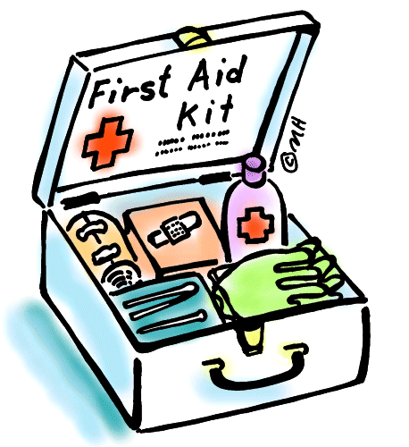All medicines should be in the original container bearing the manufacturer’s instructions for administration, dosage, and storage (the school may refuse to administer any medicines supplied in inappropriate containers).
* Medications must be renewed when required as the school cannot administer out-of-date medications.

If your child uses an inhaler, you will need to complete the School Asthma Card and Consent form which is included in the pack of forms. If your child uses an epi-pen, please let the office know so that more details can be obtained from you and additional forms completed. These will be kept in the classrooms and administered by staff as and when required.

**School Uniform**

At Loxley, we aim to make our uniform as flexible as possible for parents, so generic uniform such as trousers, skirts, shirts and blue jumpers and cardigans (without the school badge) can be purchased from a variety of outlets, particularly as they can become messy during the course of their learning! Should you wish to purchase items with the school badge on, including polo shirts, jumpers, cardigans, the Loxley CE Community Primary School book bag or school fleece, these can be ordered online via Myclothing, an online ordering service - http://myclothing.com.

* Bright blue sweatshirt or cardigan
* White or light blue polo shirt or white shirt
* Grey trousers, skirt or shorts
* Plain grey/black socks or tights
* Black school shoes *(no ankle boots or trainers)*
* No jewellery *(unless worn for religious reasons)*
* No nail polish to be worn and long hair to be tied back
* For PE: black or navy blue shorts, white t-shirt and pumps/trainers *(plus warm jogging bottoms and long-sleeved sweatshirts/hooded tops in winter)*
* For Forest School: Old clothes and shoes, suitable to the weather conditions *(e.g. waterproof boots following wet weather; hats, scarves, gloves for cold weather)*
* Fleeces, caps and book bags with our school logo *(optional)*



**Rules and Rewards at Loxley**

At Loxley we have a structured approach to behaviour management and rewarding good behaviour. We celebrate hard work, effort, perseverance and achievement with House Points which are earned for your designated colour team.

To encourage all to flourish at Loxley C of E Community Primary School, we attempt to follow our Guiding Light principles in all we do.

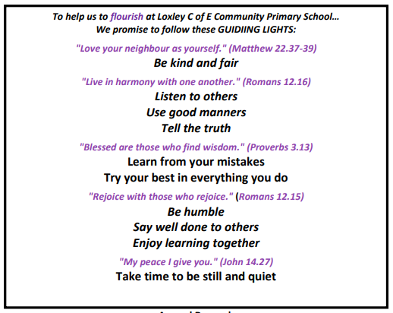

We reward behaviour that lives out and demonstrates these Guiding Light principles using ‘Catch Me Cards’. When a child is ‘caught’ being kind, loving, generous, making good choices or helping others, they are rewarded with a stamp on their ‘Catch Me Card’. When they have earned 12 stamps, they visit the Head of School and receive a certificate in our weekly celebration assembly.

The weekly Celebration Assembly is a chance for the whole school community to gather and share in the successes of the week. Each class nominates a Star of the Week and House Point totals as well as ‘Catch Me Card’ achievements are celebrated.

Our Emotion and Behaviour Regulation Policy (which can be found on our website) outlines the rewards and sanctions we have in place in school.

We actively encourage:

* Respect for each other, ourselves, the environment.
* Understanding, tolerance and acceptance of others.
* Mutual care, consideration, thoughtfulness, courtesy.
* Co-operation and willingness to share.
* Self-discipline: taking responsibility for our own actions.
* Regular or improving attendance.

We actively discourage:

* Physical aggression and bullying including online bullying.
* Verbal aggression, including racist comments, threatening, name calling, lying, defiance.
* Theft and vandalism.
* Other antisocial behaviour, e.g. spitting, teasing, interfering with other people’s work.
* Misuse of space, equipment or materials.
* Rudeness and discourtesy.

We work closely with parents to understand the root of any poor behaviour choices and communicate regularly in order to support our children.

**And finally …**

Loxley School is a wonderful environment, where the children know each other really well, look after each other and care for each other. We are extremely proud of our nurturing, family feel and cannot wait to welcome your child.

**TERM DATES – ACADEMIC YEAR 2022-2023**

**AUTUMN TERM 2022**

Wednesday 7th September – Friday 21st October

Tuesday 1st November – Friday 16th December

**SPRING TERM 2023**

Wednesday 4th January – Friday 17th February

Monday 27th February – Friday 31st March

**SUMMER TERM 2023**

Monday 17th April – Thursday 25th May

Monday 5th June – Tuesday 25th July

**TEACHER TRAINING DAYS**

**(school closed to children)**

Monday 5th September 2022

Tuesday 6th September 2022

Monday 31st October 2022

Tuesday 3rd January 2023

Friday 26th May 2023



**Contact Details**:

Loxley C of E Community Primary School

Main Street,

Loxley,

Warwickshire

CV35 9JT

Tel: 01789 840211

E-mail: [admin3040@welearn365.com](mailto:admin3040@welearn365.com)

**For events and news, regularly check the school website:** <https://www.loxleyprimaryschool.co.uk/>

We endeavour to email our communication where possible. Please ensure you let us know about any changes to contact details.