

**Event: LEAF Afternoons**

**Loxley Enrichment and Flourish Afternoons**

|  |  |
| --- | --- |
| **Purpose** | * To allow children to develop a range of ‘life-skills’ such as teamwork, cooperation, discussion and debate, as well as developing their knowledge and understanding of British Values and current affairs. * To support mental health and well-being by giving time for reflection, fun and mindfulness. * To support the wider development of our children and give more opportunities for children to take on leadership roles and respond to role-models. |
| **Date** | Every Thursday |
| **Location** | In school and on the community field |
| **Start time** | 2pm |
| **Finish time** | By 3pm |
| **Organisation** | * Children will meet in the hall and split into their colour teams. Pupils have been re-organised into Houses (colour teams). * Each team will carry out a planned activity each week. They will then move onto the other two activities over the next two weeks.   **Activity one: Singing, music and movement and yoga with Miss Geldard.**  Research shows that singing can improve physical and mental health, as well as promote social bonding. Music making, exercises the brain as well as the body, and singing is particularly beneficial for improving breathing, posture and muscle tension.  **Activity two: ‘The World Today’ with Mrs Woolley**  Picture news allows children to learn about what’s happening in the world, using current affairs to inspire passion, giving them a voice to share their thoughts and ideas. They will think about British Values, Christian values and form their own opinions in answer to a weekly ‘Big Question’.  **Activity three: Forest School with Mrs Thurkettle and Onside.**  An opportunity for exploration and supported risk-taking, developing confidence and self-esteem through learner inspired, hands-on experiences in a natural setting.  *Buddy Reading: Alongside activity 1 & 2, the children will read together, alternating between young reading to old and older reading to young. Sharing books brings pleasure to all and inspires children to read and enjoy sharing books, promoting reading for all.* |
| **Changes to Routine** | * Every child will have the opportunity to take part in Forest School once every three weeks. This is a change for Acorns and Horse Chestnuts, who (until now) have been going every week. * Staff are adjusting their timetables to accommodate this change. |
| **Reminders** | * Please wear PE kit every Thursday. This will need to include long sleeves and joggers/leggings for the weeks that your child will be at Forest School – we don’t want any scratches. * A timetable will be attached so that you know what activity your child will be doing. |
| **Queries** | If you require any further information or have any questions, please refer to the letter sent earlier this week and then do not hesitate to contact the school office via [admin3040@welearn365.com](mailto:admin3040@welearn365.com) |

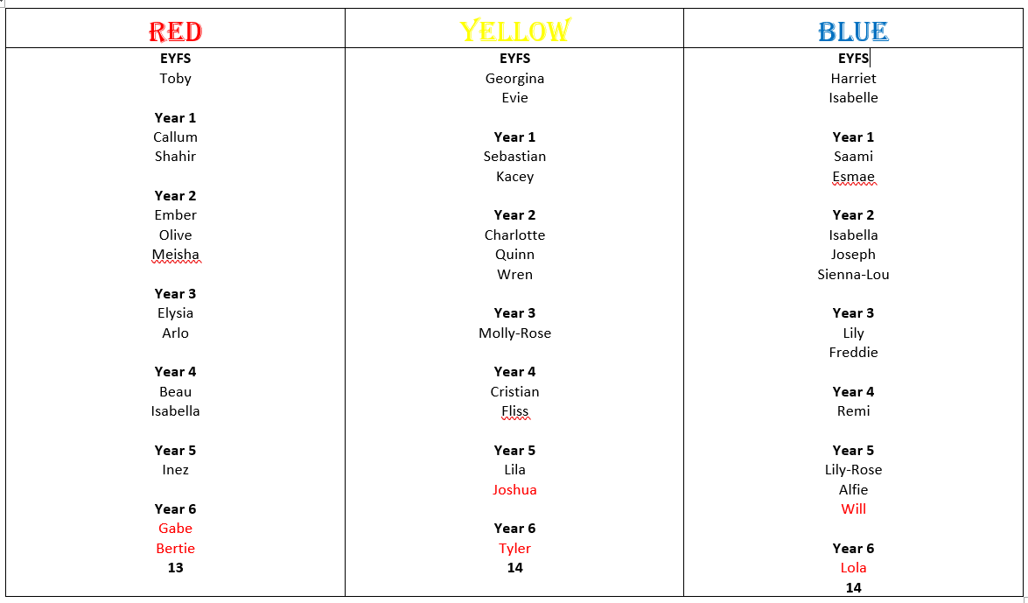

**Houses**

|  |  |  |  |  |
| --- | --- | --- | --- | --- |
|  | **9 March** | **16 March** | **23 March** | **30 March** |
| **Activity 1**  Music and Movement | **RED** | **BLUE** | **YELLOW** | **RED** |
| **Activity 2**  The World Today | **YELLOW** | **RED** | **BLUE** | **YELLOW** |
| **Activity 3**  Forest School | **BLUE** | **YELLOW** | **RED** | **BLUE** |