**Weather station data recording**

**Beaufort scale**:

Use this scale to measure and record the wind speed and description. Go outside and stand in the wind for a while. Use the description to decide how windy it is and record the data. It might be helpful to place a flag outside to help you.

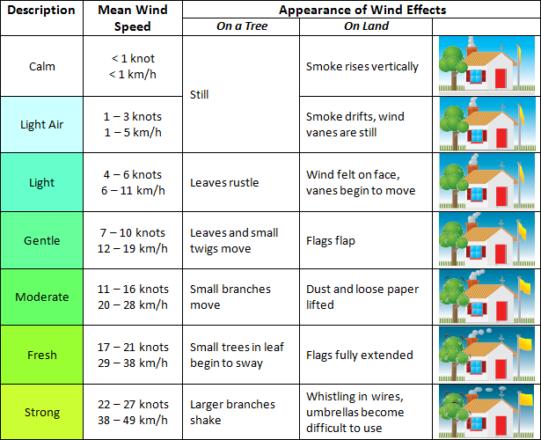

**Measuring cloud cover**

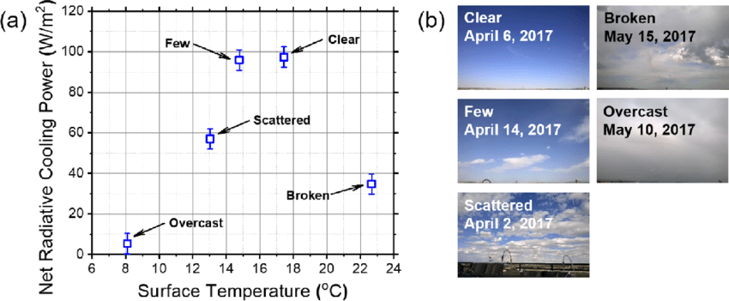

To measure cloud cover you can use a description as shown in the photographs. Ranging from a clear sky to a completely covered sky or overcast.

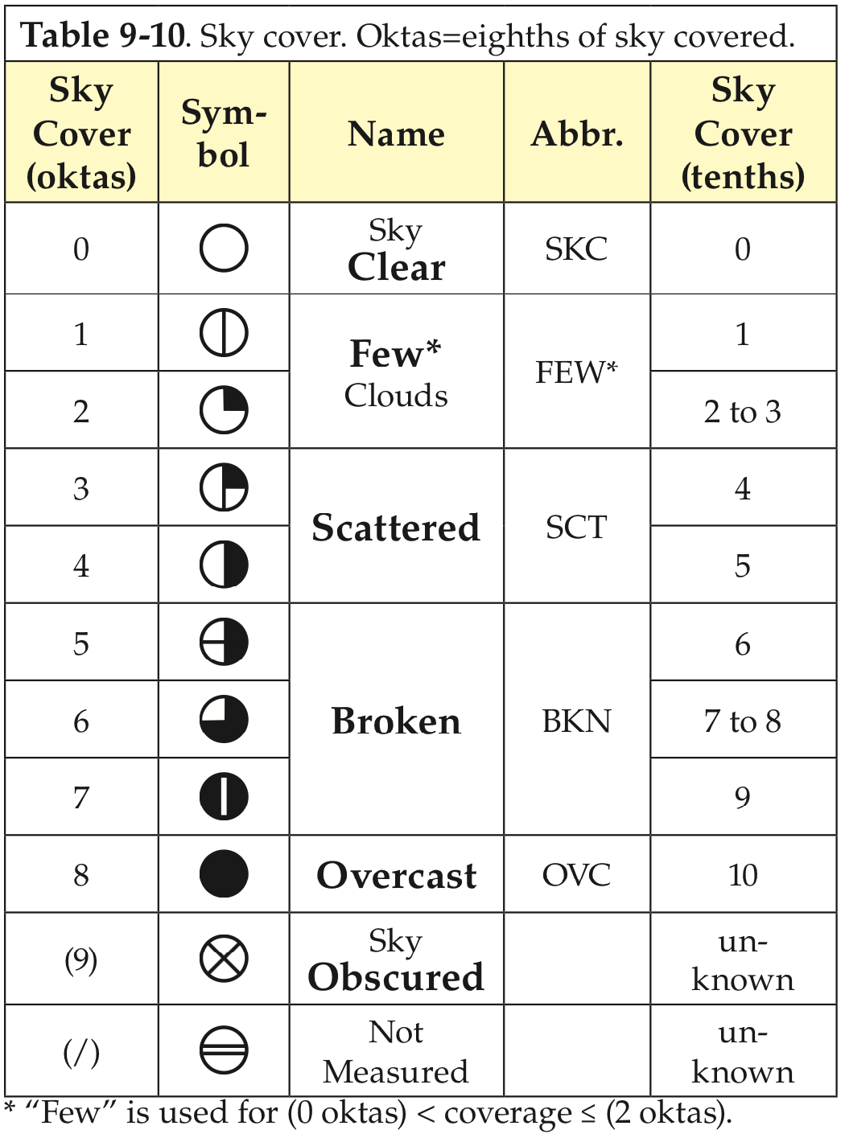Weather observers measure the cloud cover in Oktas, or eights. A sky that is completely covered in cloud is called overcast and has 8 oktas of cloud.